Open Thermostaat v1.1

# Pins

* Buttons: 6, 7
* DS18B20 (temp): 5
* Relay/LED: 3
* Display: CS = 9, DC = 8 (and RST = RST)
* RD module: CS = 10

# Remarks

* R6: Short
* DS18B20: Right-Bottom pin needs to be connected with 3v3 (one but last pin on top header)
* Display: Place header on the top
* Q1 and R4 are optional (instead of relay); JP2 and JP3 as well

# Arduino Libraries

* Button, LED and relay: See examples “Digital”
* DS18B20:

<https://github.com/milesburton/Arduino-Temperature-Control-Library/>

<http://playground.arduino.cc/Learning/OneWire>

* Display:  
  <https://github.com/adafruit/Adafruit-ST7735-Library>

<https://github.com/adafruit/Adafruit-GFX-Library>

**Resistors**

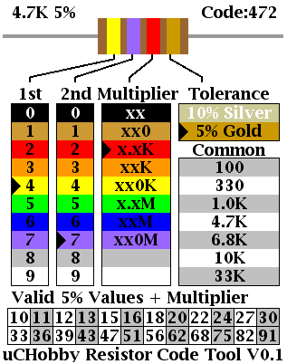

# Schematic

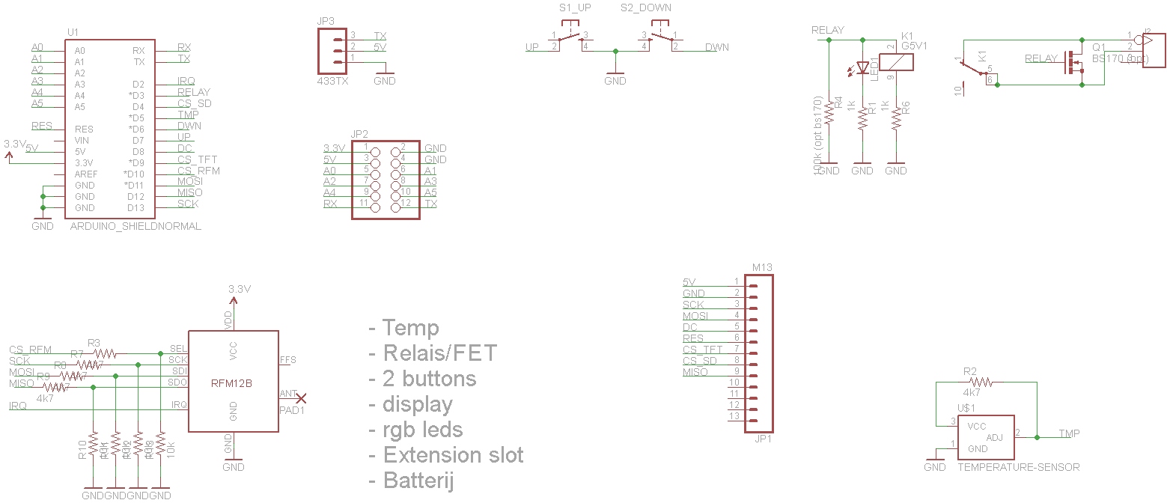

# PCB

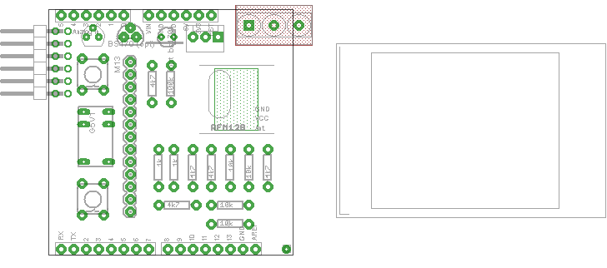

# Soldering instructions

**Notes:**

1. Short leg of a LED is the ‘ground’
2. R6 can be found when you zoom in maximum in OTShield v1d_pcb.pdf
3. The optional 100K on R4 isn’t included in the kit.
4. It is advisable to add a shrink sleeve to the kit for the protection of the short

## Step by Step soldering

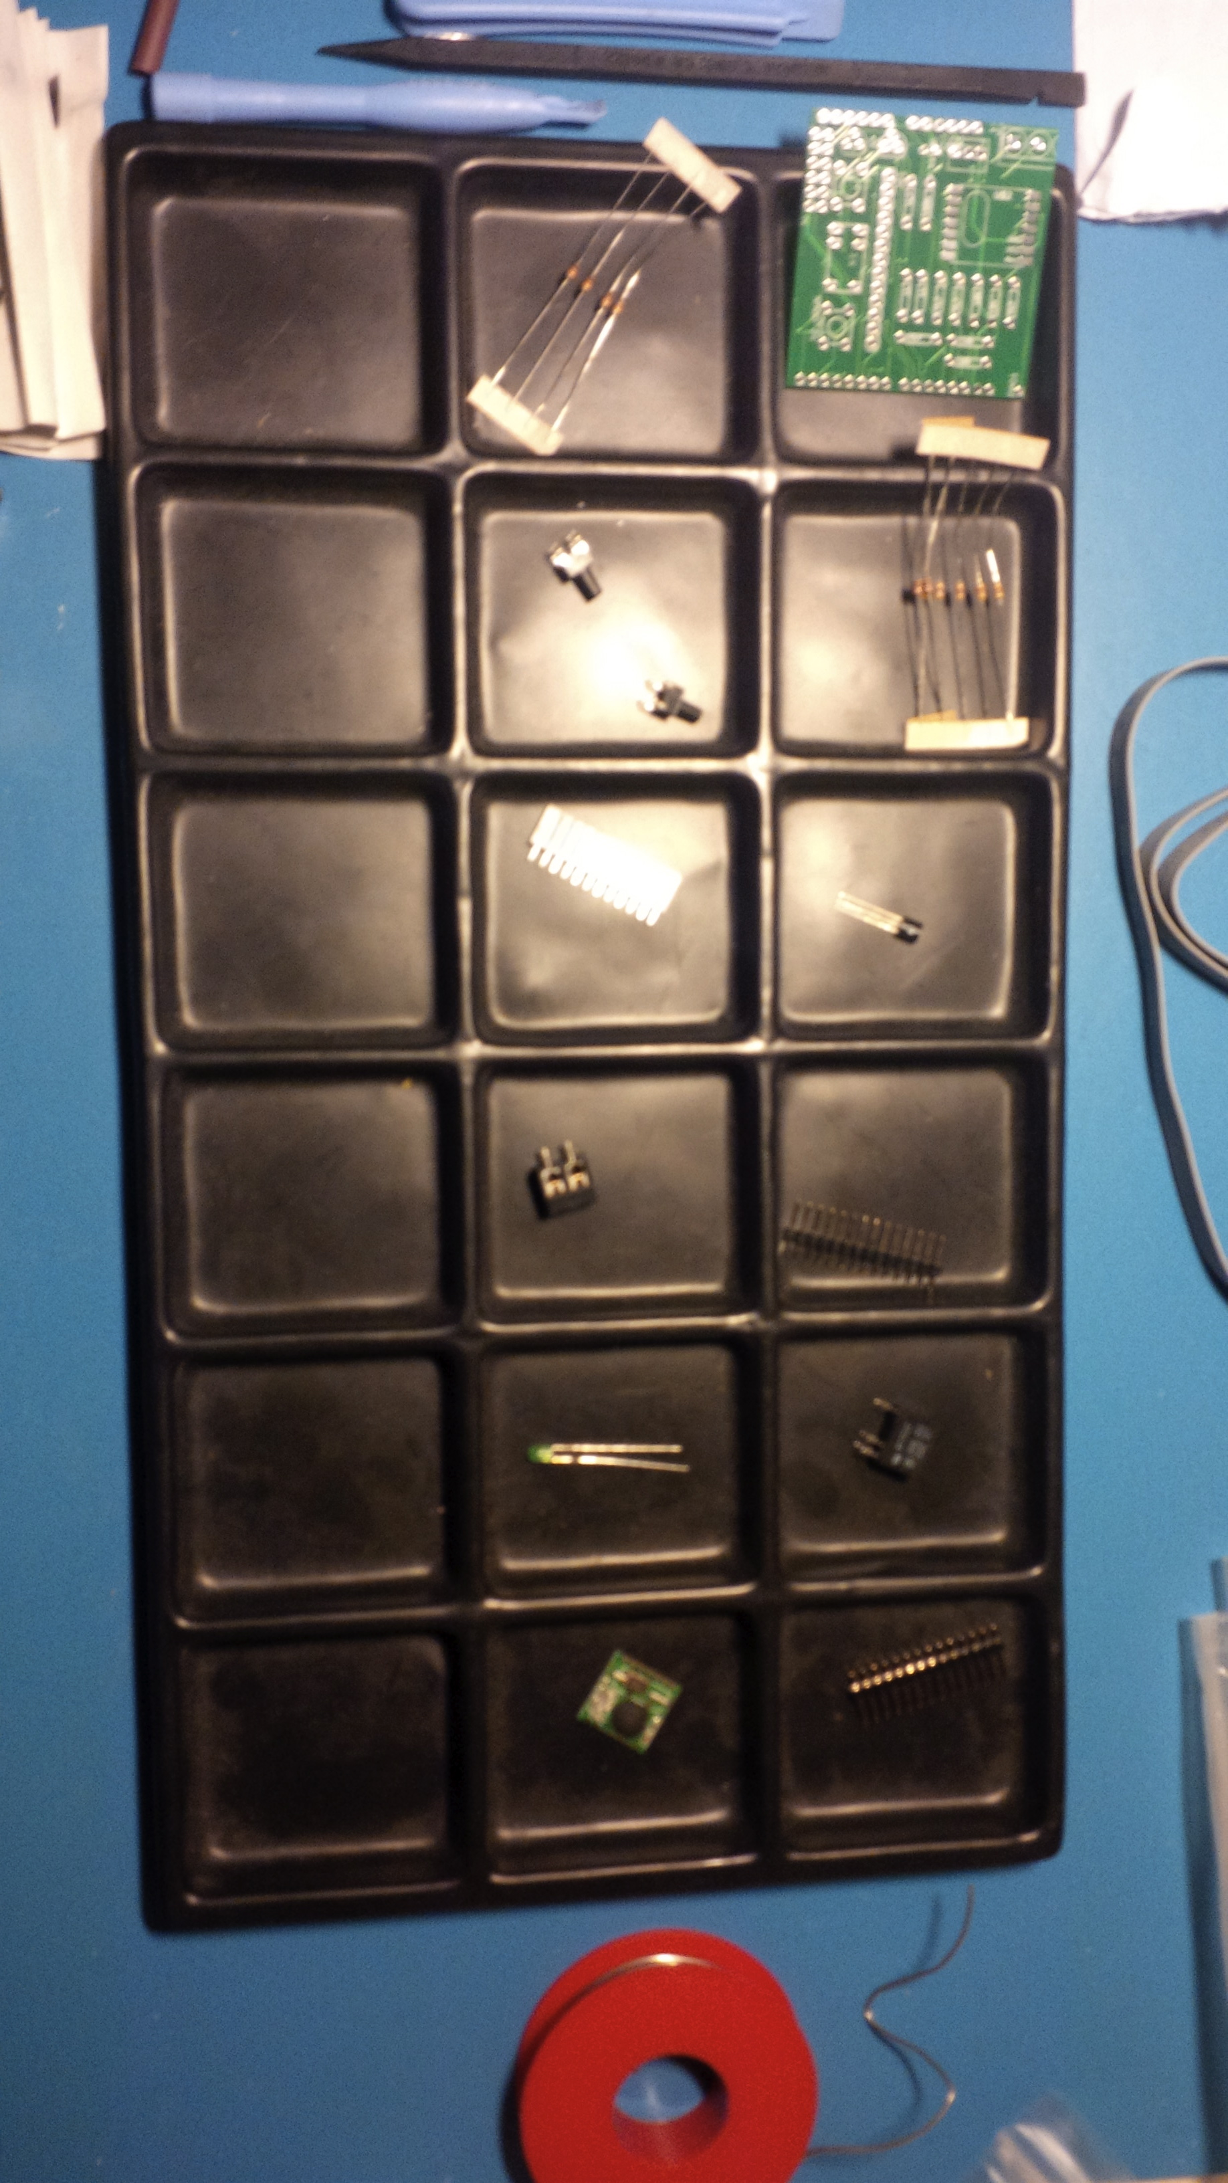

1. **LCD Pinheader**  
   *Soldering tip: Put the other pinheaders onto the board so you can easily solder this pinheader in a 90 degree angle.*

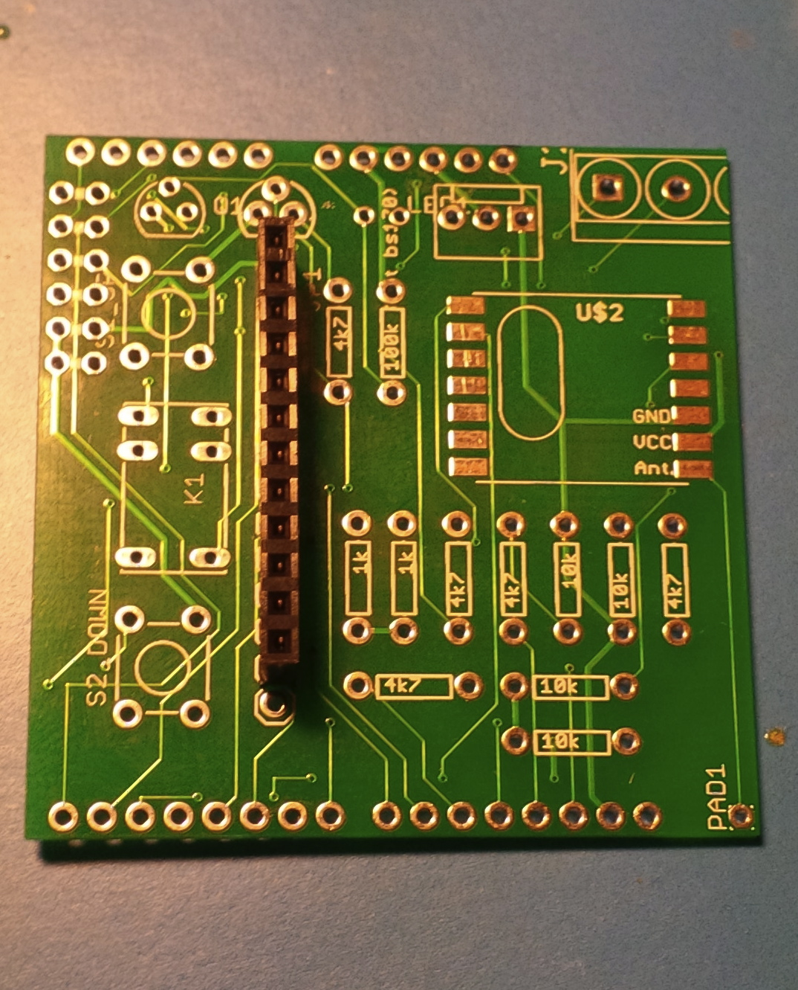

1. **Resistors**  
   Put all the resistors into the board and solder them one by one.  
   *Soldering tip: Check on both sides of the board if the soldering connects both the top and bottom.*

Note: 100k on R4 is optional and isn’t included in the kit.

1. **Relais (Omron G5-V1)**
2. **Buttons**Just push the buttons onto the board. It doesn’t matter if they are connected reverse. So no need to worry about that.

**Note: The connectors can easily break!**

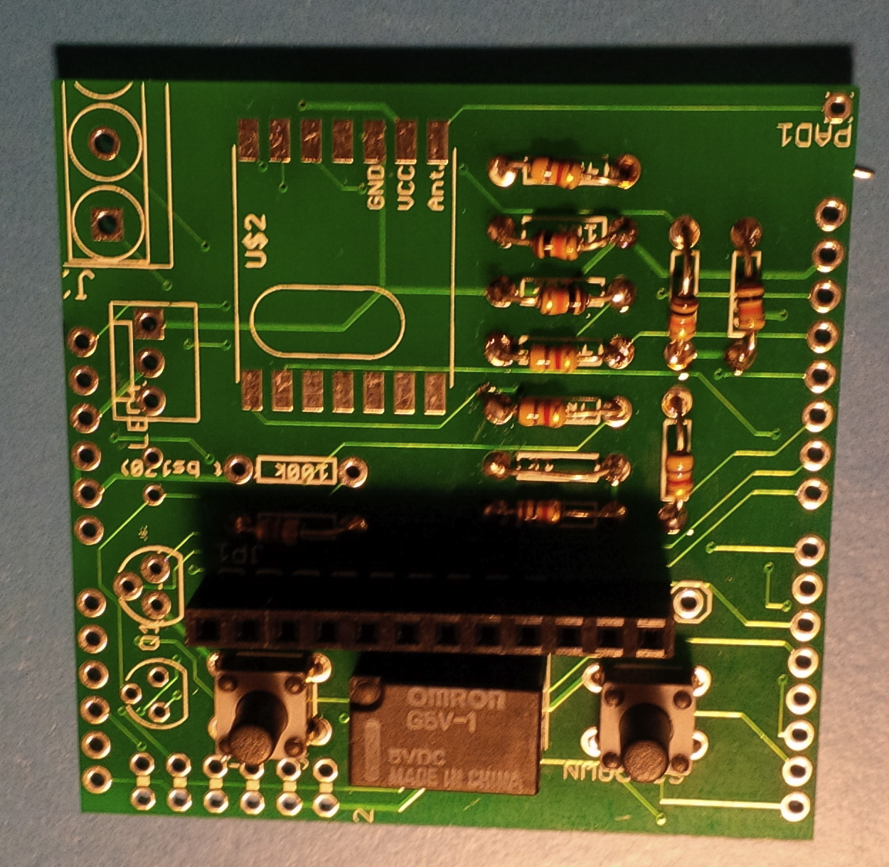

1. **Temperature sensor**At this stage you need to take into account that we need to short between the temperature sensor and the 3V3. For this purpose you can take a cut leg of one of the Resistors and ensure it is soldered together with the temperature sensor.
2. **Put a shrink sleeve around the short**
3. **Solder the short [right bottom pin – 3V3]**

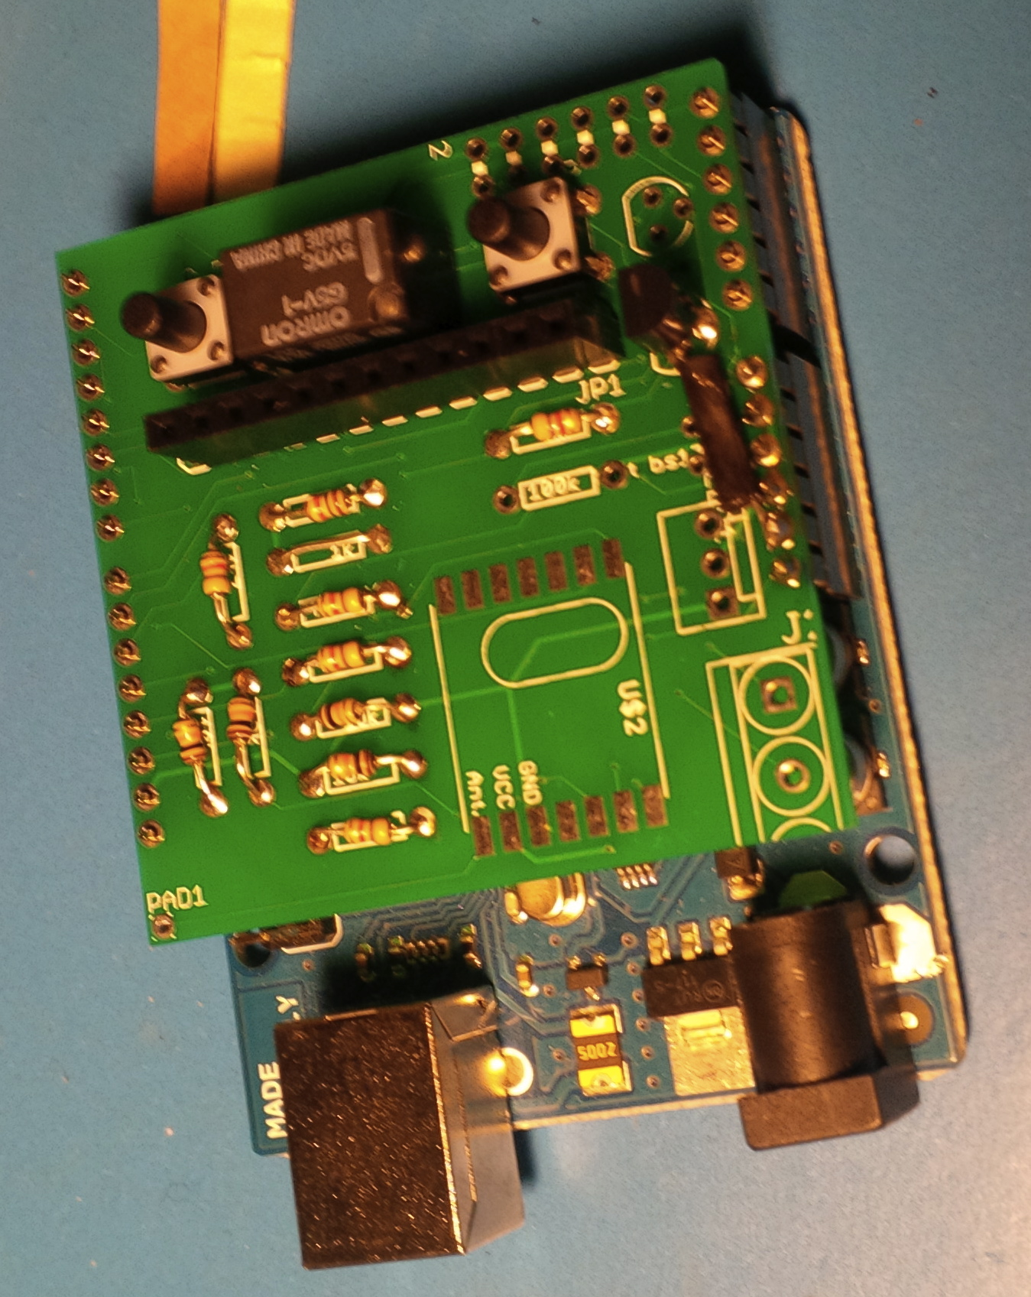

1. **Headerpins connected to the 3V3**
2. **Shrink the shrink sleeve**
3. **Led**   
   *Tip: ground is the shortest connector. This ground needs to be put into the hole the farest from the temperature sensor and thus closer to the 1K* ***Ω***

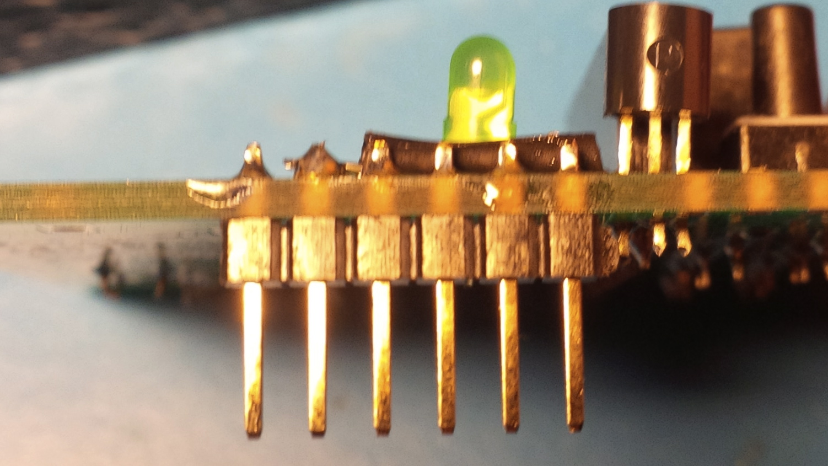

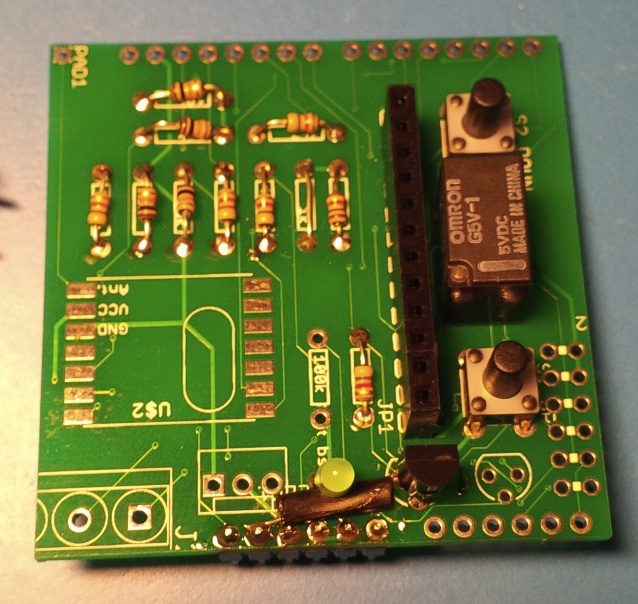

1. **Remaining headerpins**

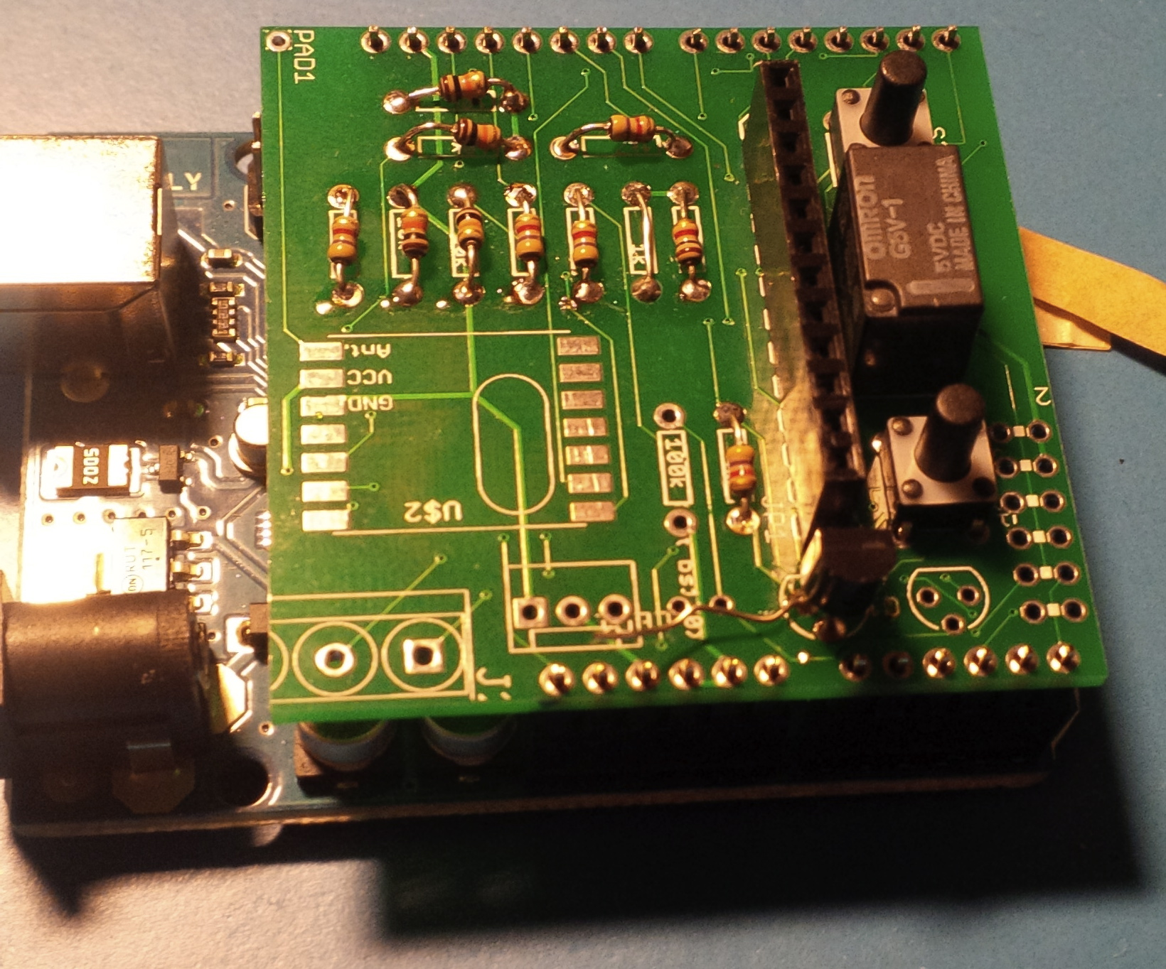

1. **Kettle connector**

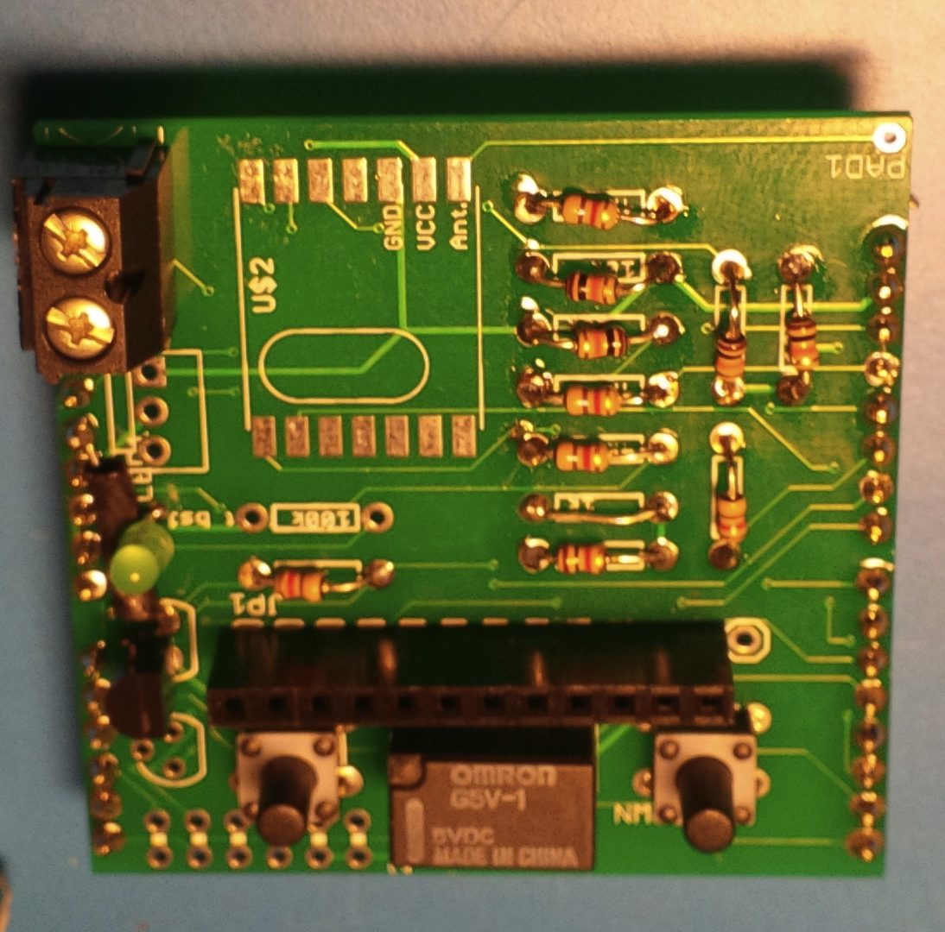

1. **RF Module**  
   The crystal needs to be placed at the display side. Once you have soldered one connection the module remains in it’s place.

